Knights of Columbus Ware
Council 7909
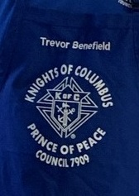
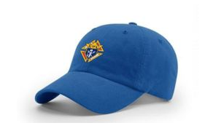
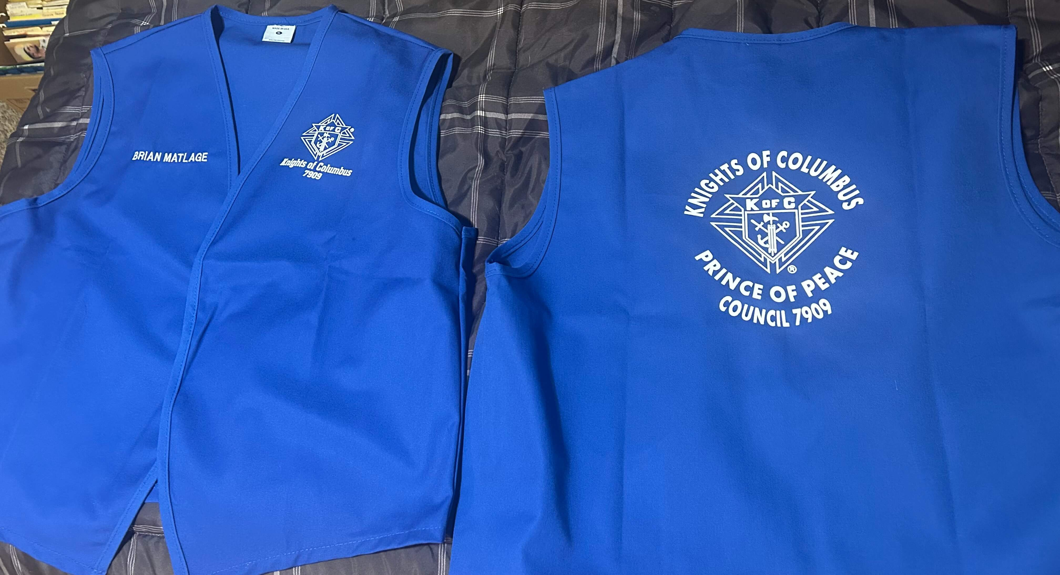

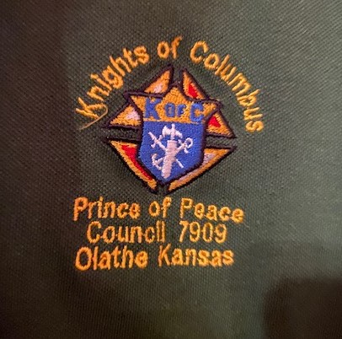
Polo - 4.4oz. Poly. Snag Proof, Odor Fighting, Moisture Wicking, Tag Free
S-XL - $28.00 each
2XL - $29.00 each
3XL - $32.00 each
4XL - $34.00 each
5XL - $36.00 each
6XL - $36.00 each
Above prices include: The Polo and embroidery of the K of C logo on Left Chest.
Hat - 65/35 Poly/Cotton, $14.50

Vest 15.00
Name embroidery 18.00

Apron - Free with Limited Quantity

Name | Phone | Address
Shirt/Vest (Please State) | Size | Quantity | Total Price
Apron | Quantity | Name (First & Last)
Hats | Quantity | Total Price


https://square.link/u/Bss3cRPT

